Design Doc
- My primary focus for the final project is sound
- I want to make something that brings someone the feeling of playing an arcade game, so the 3-5 minute game that I want to make is an arcade game inspired by Super Bubble Bobble. Right now, I’m thinking the games theme will be based on a dog saving its owner. The dog shoots affection hearts at the enemies and defeat them just like in bubble bobble. The dog will venture through the owner’s work defeating the other employees and then finally saving the owner from his boss, so that the owner can finally play with his dog.
- Design example Super Bubble Bobble 1986 Taito Mame Retro Arcade Games - YouTube
Art – Player, Items, and UI: simple pixel art the same as the game
Background and Platform: a static version of stick it to the stick man, one color, boring office objects that the player can’t interact with, and a from that matches and doesn’t change from level to level
Enemy’s: more detailed pixel art
Art example 1 Super Bubble Bobble 1986 Taito Mame Retro Arcade Games - YouTube
Art example 2 (1) NEW SAITAMA One Punch Man Character In Stick It To The Stickman - YouTube
Art example 3 (1) Metal Slug 1: Full Walkthrough - YouTube
Sound – try to keep the same up beat theme of the original title with the chiptune sounds. Maybe have jazz or elevator music playing for that work grind feel or the office feel
Sound example Super Bubble Bobble 1986 Taito Mame Retro Arcade Games - YouTube
Sound example (1) Sixteen Tons - YouTube
Sound example (1) Elevator Music - 1 hour - YouTube
sound example (1) Elevator Music - Gaming Background Music (HD) - YouTube
sound example Chet Baker - Almost blue - YouTube

Tone – comical action platformer
Tone example Super Bubble Bobble 1986 Taito Mame Retro Arcade Games - YouTube
- Game controls – the game is meant to be played on only a computer. W, A, S, D and up arrow, left arrow, right arrow, down arrow to move. P to pause the game and r to resume the game. Spacebar to fire the projectile.
- Events/Conditions and Actions in place:

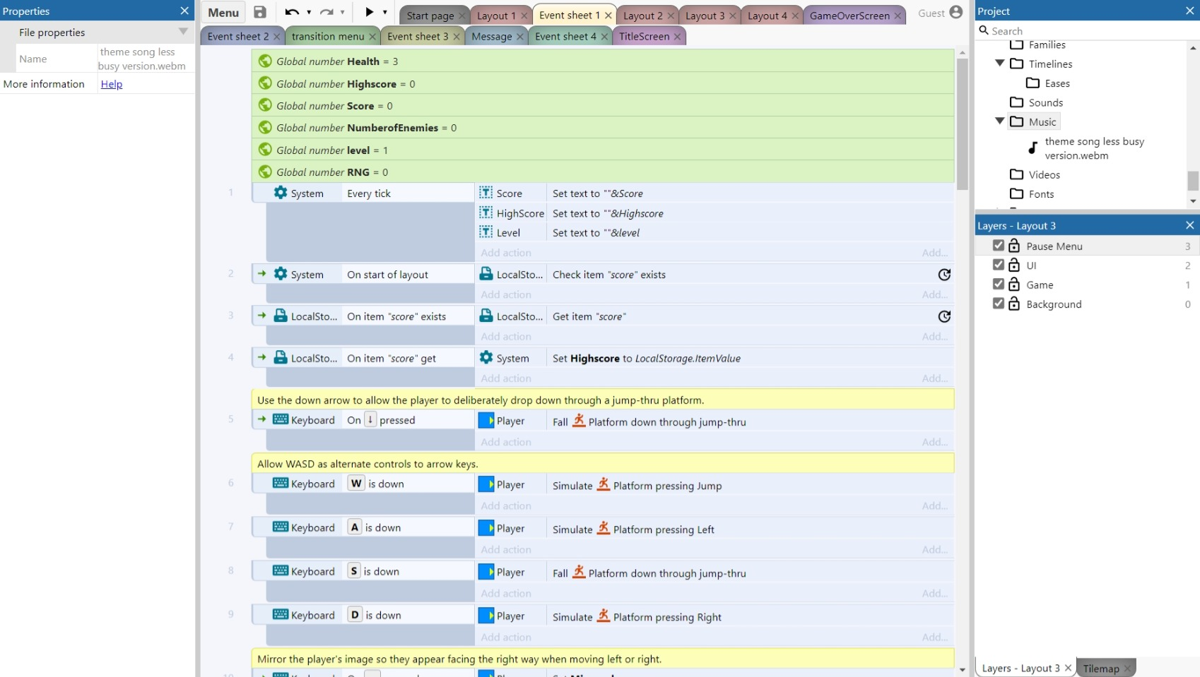

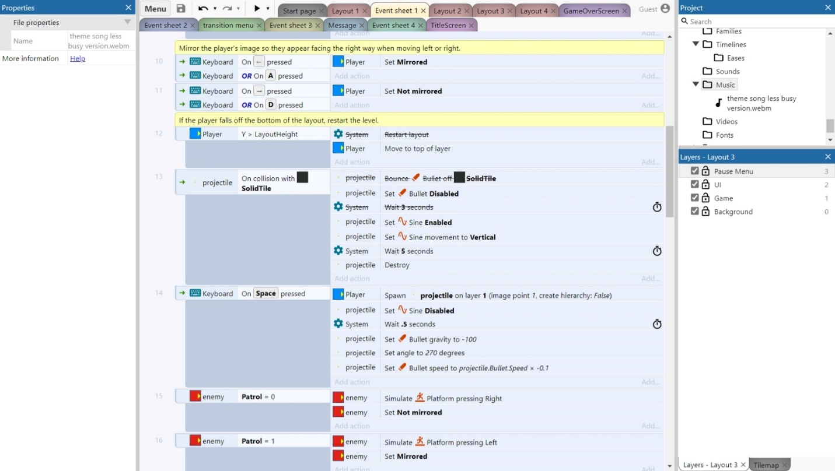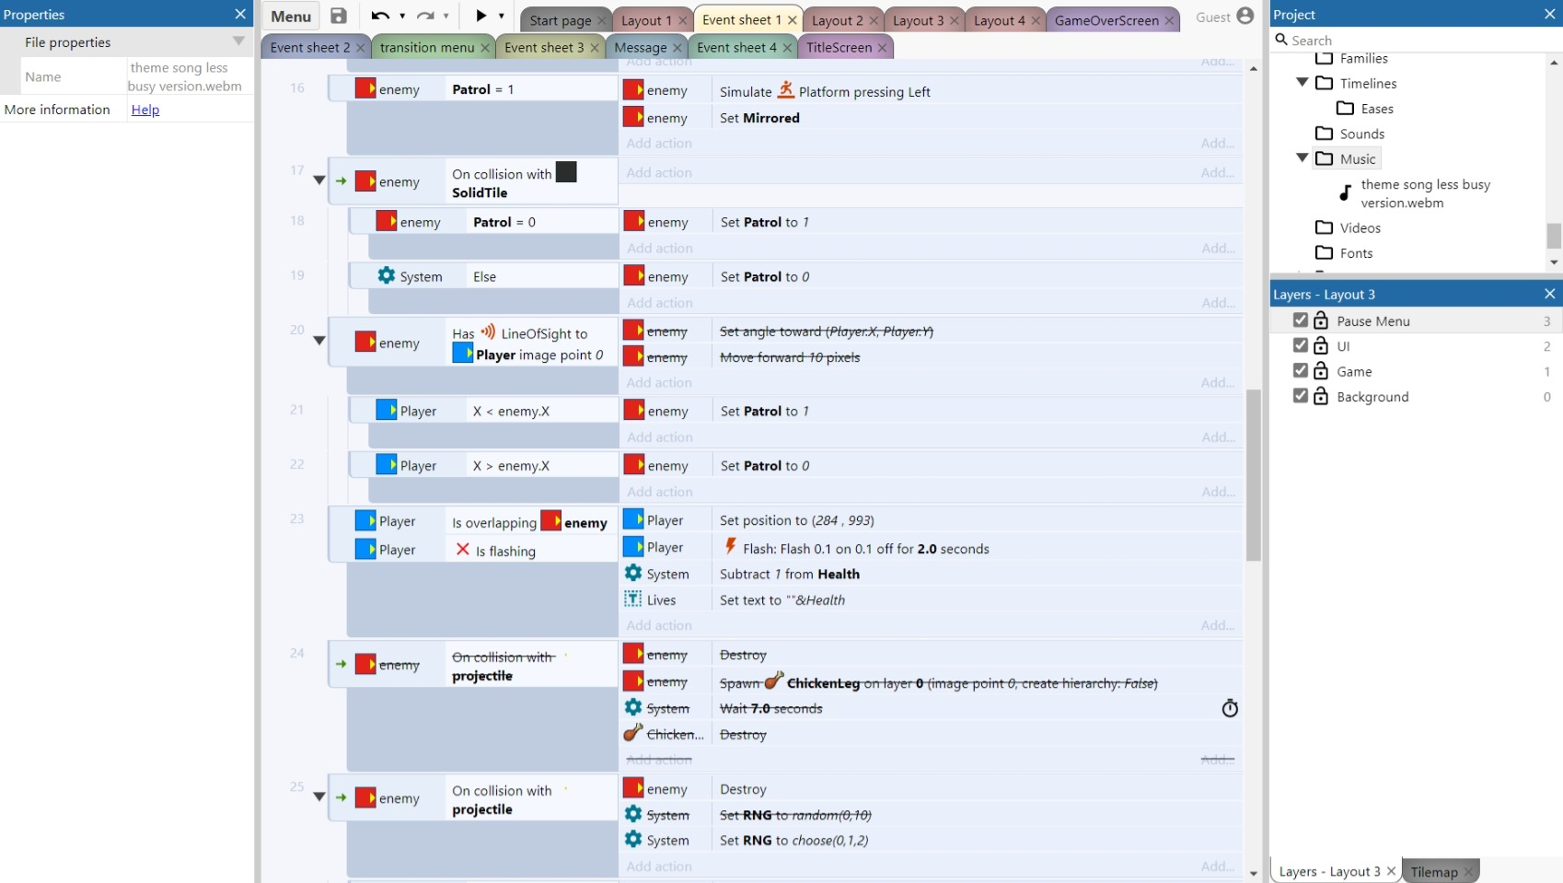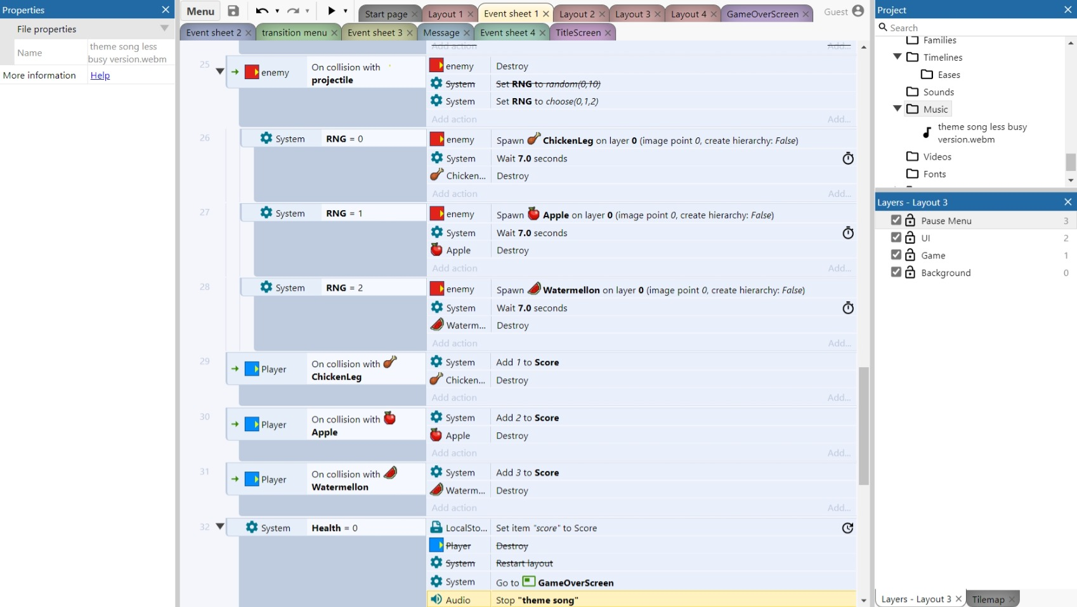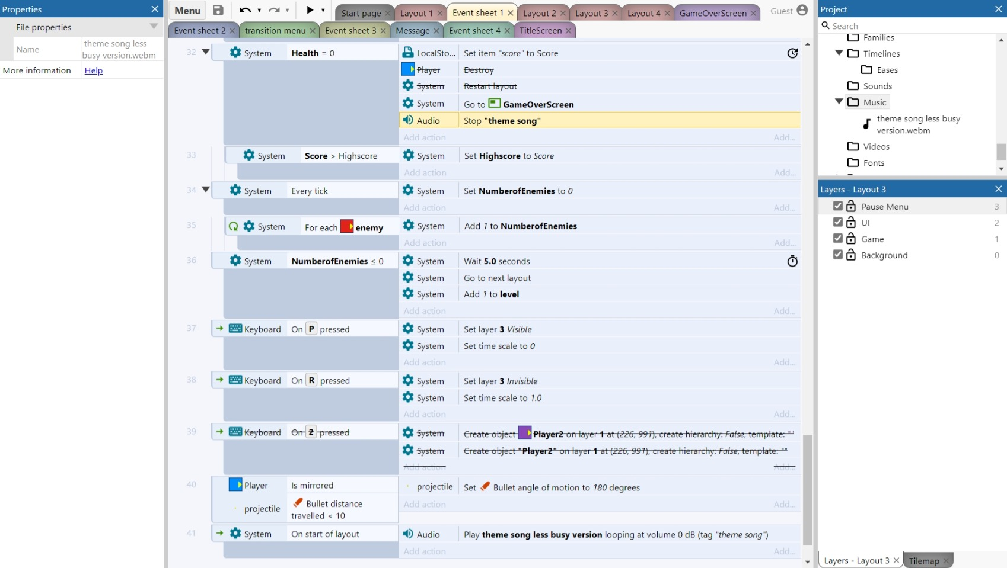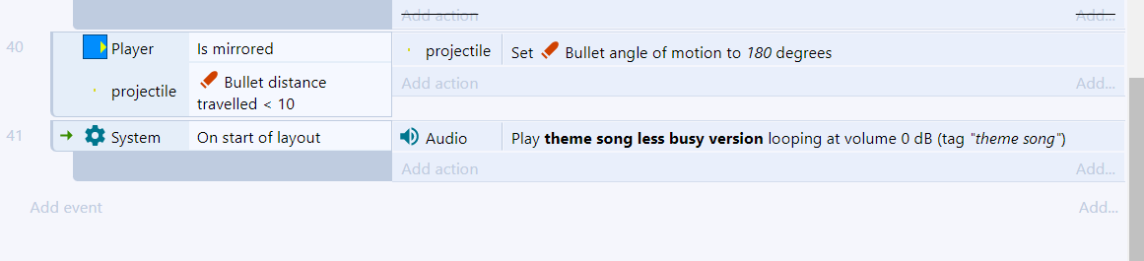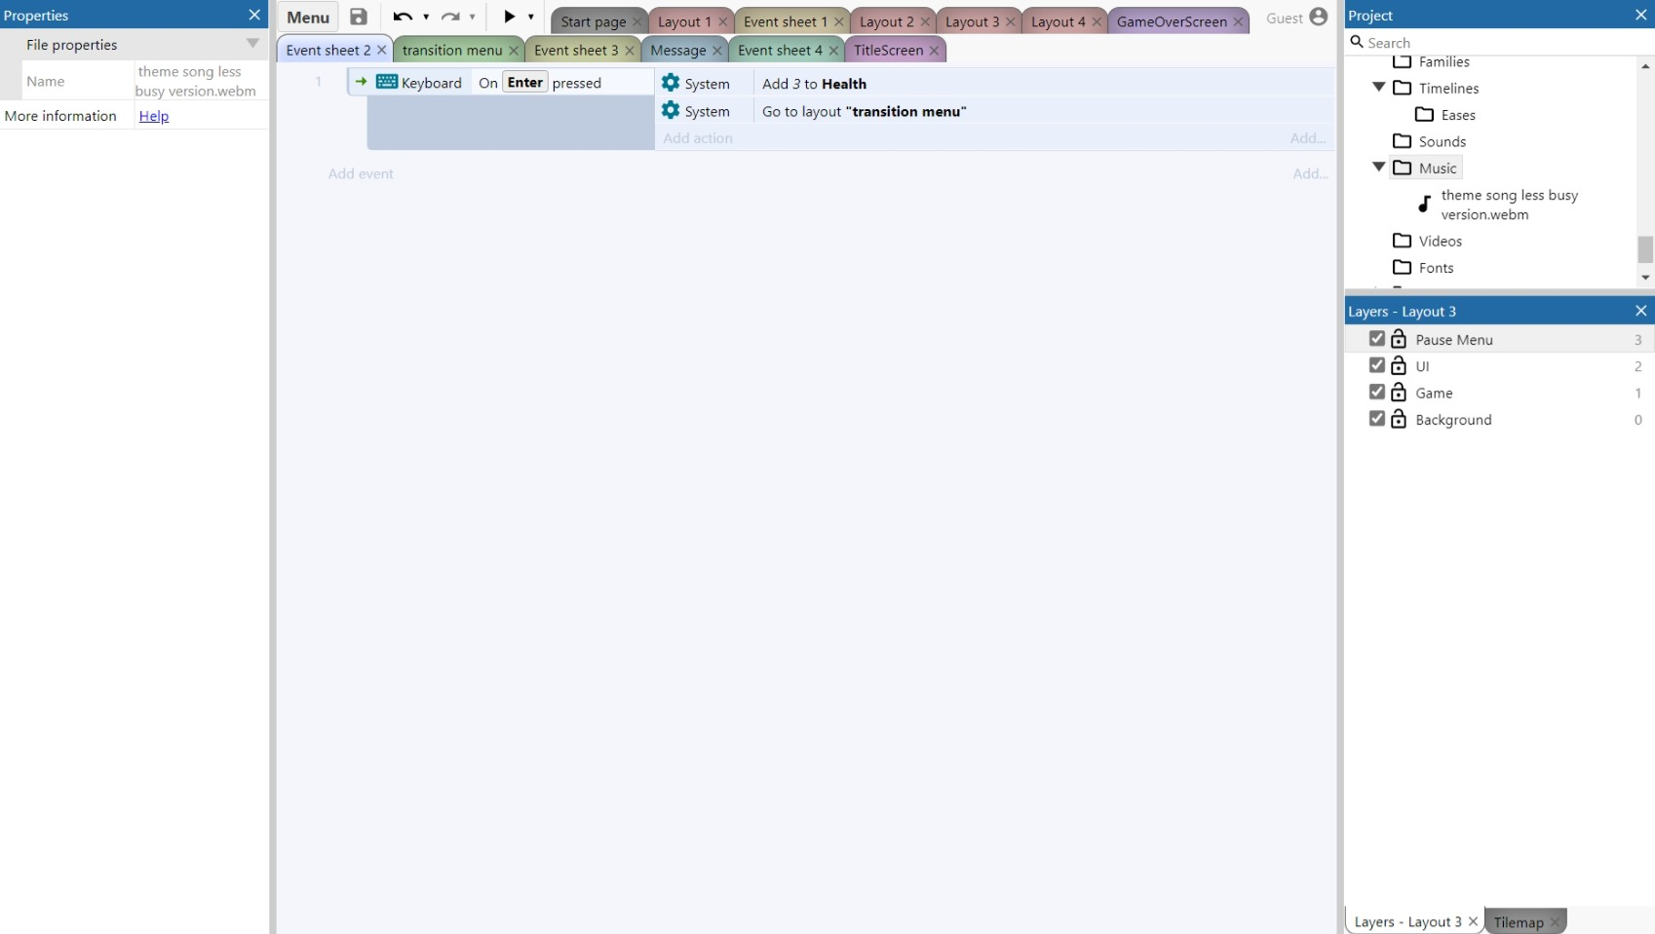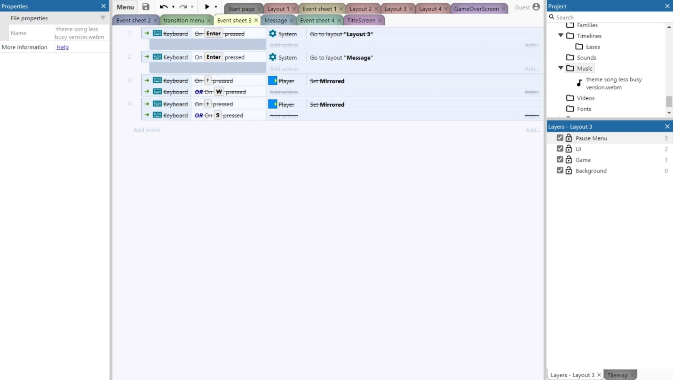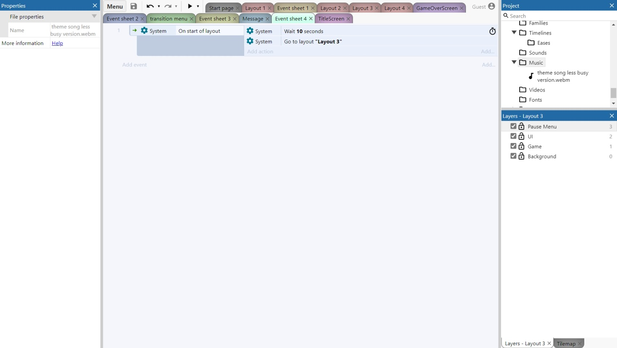
- Events/Conditions and Actions still needed:
- Better enemy ai
- Work on the projectile
- Work on the local storage
- Work on the level UI update
- Possibly adding a second player to the game
- Add event to randomly pick new music to play
- Add sound effects in the game for projectile and player interactions
- Add animations
- Try to add a level transition like the original game
- Add a change in enemy behavior if they get out of the bubble
- Possible add high score leader board and progress layout
- Add different types of enemies with different behaviors
- Add sound effects to play on button clicks
- Add ui

- Tutorial videos:
- How to Make a Menu System in Construct 3 - YouTube
- How to turn any sprite button in construct 3 [Very Easy] - YouTube
- Create Custom Buttons - Construct 3 Tutorial - YouTube
- Construct 3 Tutorial: Making a Game Over and Win screen - YouTube
- Construct 3: (#8) Adding Game Over | HTML5 Game Tutorial - YouTube
- Construct 2 Tutorial - Jumper Game #PART 4 - Game Over - YouTube
- Construct 3 Platformer Tutorial - 6 Restart When Die - YouTube
- How to Make a RNG - Construct 3 Tutorial - YouTube
- Picking Multiple Randoms From a Set - Construct 3 Tutorial - YouTube
- Construct 3: Random spawn pickable objects - YouTube
- Spawn Waves of Enemies - Track enemies on Screen - Construct 3 Tutorial - YouTube
- construct 3 New High Score - Save Game Tutorial - YouTube
- 2. Global variables and dynamic text - YouTube
- Construct 3 Tutorial - Updating the Score - YouTube
- Every construct 3 behaviour explained with examples in 15 minutes! - YouTube
- Construct 3 Tutorial #1 - Moving Platforms - Sine Wave (vertical, horizontal, diagonal) - YouTube
- Construct 3 Tutorial - Floating and Following an object with fluid motion - YouTube
- Construct 3: Bullets (top down) - YouTube
- Construct 3: Bullets - YouTube
- Basic AI Enemy Follows Player (Construct 2) - YouTube
- Throw Objects - Physics - Construct 3 Tutorial - YouTube
- Construct 3 Tutorial: Connecting Levels into a Sequence - YouTube
- Construct 3 Platformer Tutorial - 21 Adding Bullet Shooting System and Fix Idle Animation Direction - YouTube
- Construct 3 - Enemy follow player - pathfinding tutorial - YouTube
- Construct 3: Enemies chase player - YouTube
- Construct 3 Platform Game Tutorial - Part 5 - Enemy AI - YouTube
- Construct 3 Tutorial - Advanced Enemy Ai [ 01 ] - YouTube
- Create Your Own Pacman Game In Scratch - Part 3 - YouTube
- Making Maze Game with Construct 3 - Easy Game Development - YouTube
- Pac Man - Construct 3 - Logic Minds - YouTube
- Construct 3 Pacman - Ghosts 4 Moving to the First Marker - YouTube
- Construct3 Pacman - Ghosts 3 Adding the Ghost - YouTube
- Construct 3: New level - YouTube
- Construct 2: Movimentação do PacMan - YouTube
- Construct 3 Platform Game Tutorial - Part 2 - Moving Platforms & Coins - YouTube
- How to CHANGE LAYOUTS in Construct 2 or 3!!! - YouTube
- Having a Sprite Fall From the Top of the Screen: Programming in Scratch 2.0 - YouTube
- Construct 3 - Layouts & Layers - YouTube
- Construct 3 Demo's : portal between layouts - YouTube
- More Customizable Jump in Construct 3 - YouTube
- Better Jumping Mechanic - Construct 3 Tutorial - YouTube
- (1) Construct 3:Rotating and shooting - YouTube

- narrative details:
- Characters – (the dog), (the owner), and (the boss)
- Setting – the office building the owner of the dog works at
- Tone - comical action platformer
- Plot Points (Beginning, Middle, End) – the owner is taken away from the dog, the dog tries to rescue the owner from his job, the dog fights the boss to save the owner so that he can play with the dog at home.
- Conflict\Resolution –
- Similar titles -
style guide
Story and Plot
- All is well
- Disaster strikes owner is forced to work overtime taken away by the boss
- Ollie starts his journey to rescue his owner and bring back the good times
- Ollie meets his first challenge getting past the office workers that are trying to catch him and get him out off the building
- Ollie gets past all the office workers to have to face off against the boss who is busy standing over the owner micromanaging him
- Ollie beats the boss, and a cut scene shows Ollie and the owner relaxing peacefully at home
- Ollie looses and receives the game over screen
Character
- Loyal companion of the owner
- Loves snuggling, but compromises his goals for the desire of food
- Overcomes the struggle of the workplace rat race
Setting
Takes place in an office building. Player is reminded of this by the background objects that decorate the scene, the elevator music playing in the background, the enemy sprites, the narrative scene
The player is saving the owner and the player knows this by the narrative scene
Act 1 – Ollie relaxing with the owner
Act 2 – Owner is taken away from Ollie
Act 3 – Ollie is forced to face the demon that is the boss
The shape of the story
45°
The player must overcome in the form of combat
Beast VS. Man
The conflict ends when Ollie can defeat the boss
Tone
lighthearted fun
Type of story
The hero’s journey
Theme
Face your demons today so you can enjoy tomorrow
Happiness is the key to life
Friendship

Plot
Saving the day through kindness
Symbolism
I want the player to be reminded that there in a boring office
The audience is entering the story through a cut scene
The story is being told by Ollie the dog the protagonist
The story is delivered through cut scenes and game play
Beat Sheet

To Do List
Sound
Use the sequencer in reason to get the 8 bit sound
Guy to look up: Bog something
- 5 variation of sound effects
- 3 theme songs
Art
Background for level
Enemy- guy model and girl model 5 variation of each
Better to make a family for enemies and have different enemies with different behaviors
- Computer guy
- Security guard
- Secretary
- Boss
- Owner

- Environment at least 1 to 3
- Dog running animation

Could change elevator music to only play in the elevator and have the scenes be filled with environment sounds
Each level looks different
- Lobby
- Office floor
- Conference room
- Breakroom
- Roof
- Abandoned floor
Look for opengameart

